Introduction to Physical Fitness and Wellness

Student’s Name
Institutional Affiliation
Course Name and Number
Instructor’s Name
Assignment Due Date

Cardio Heart Rate
Activity | Intensity | THR (Bpm)
Burpees | Light | 78
 | Moderate | 89
 | Vigorous | 102
Skipping rope | Light | 82
 | Moderate | 90
 | Vigorous | 105
Push-ups | Light | 65
 | Moderate | 86
 | Vigorous | 100

Burpees | 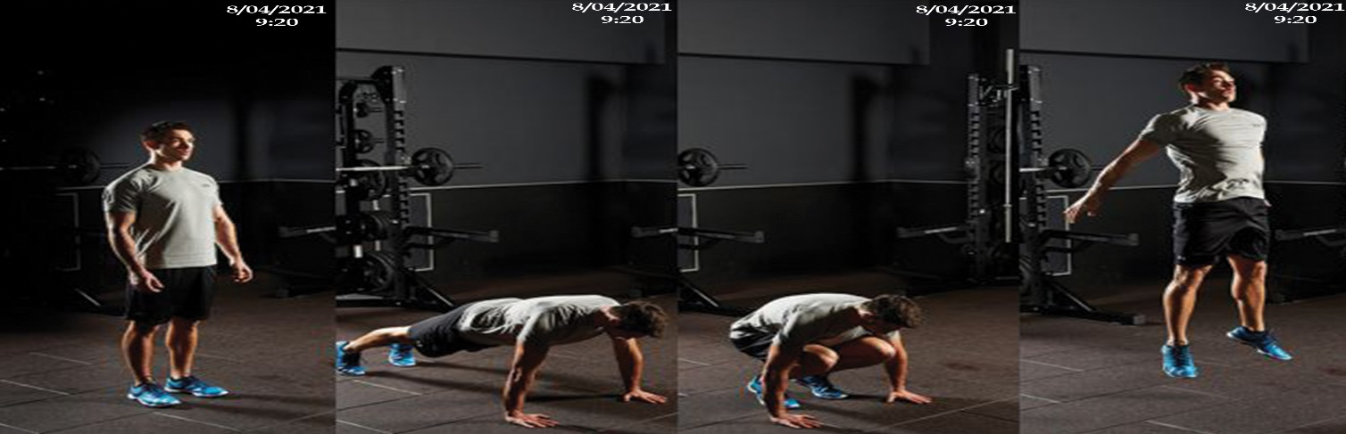

Skipping-rope | 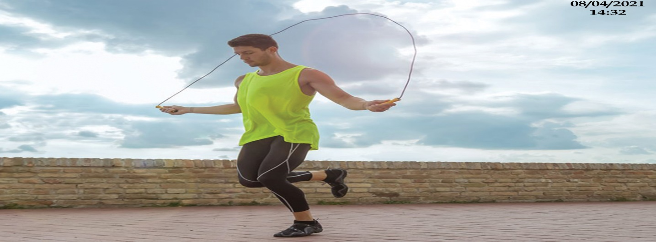

Push-ups | 